APPENDIX I: NRCan CATCH Database  Canadian ThermoCHronology Database – National Geological Data Integration Platform | 
GDAC-SA Advanced Analytics Platform RFQ | Lithodat Pty Ltd
Project Overview: The Canadian ThermoCHronology (CATCH) database is Natural Resources Canada's (NRCan) national platform for integrating low-temperature thermochronology data across Canada. Developed by Lithodat in partnership with the Geological Survey of Canada (GSC), CATCH demonstrates advanced capability in multi-decade data curation, legacy data digitization, FAIR-compliant repository construction, and national-scale geoscientific database architecture—directly applicable to GDAC-SA's requirements for integrating historical and modern geological datasets.
About the CATCH Database
Official Publication: Natural Resources Canada's Geological Survey of Canada published Open File 9225 in 2025, marking the first comprehensive compilation of low-temperature thermochronology (LTT) data for northern Canada and the foundation of the CATCH database initiative.
Authors: J.W. Powell (GSC), D.A. Kellett (GSC), F. Kohlmann (Lithodat), and M. McMillan (Lithodat/University of Melbourne)
What is Low-Temperature Thermochronology? Low-temperature thermochronometers, such as fission track and (U-Th)/He systems, are radiometric dating methods sensitive to low (<~300°C) temperature regimes characteristic of relatively shallow depths in Earth's crust. LTT provides temporal constraints on a range of important upper crustal geological processes, including:
Tectonic exhumation – Unroofing and uplift of mountain belts
Climatic exhumation – Erosion driven by glacial and fluvial processes Brittle deformation – Faulting and fracturing events
Sedimentary burial – Basin subsidence and thermal maturation Hydrothermal fluid circulation – Mineral deposit formation
Crustal heat flow changes – Geothermal evolution over time
The unique ability of LTT to unravel the thermal history of rocks renders these methods invaluable for assessing the geodynamic and surficial processes that have impacted Canada's bedrock throughout geologic time.

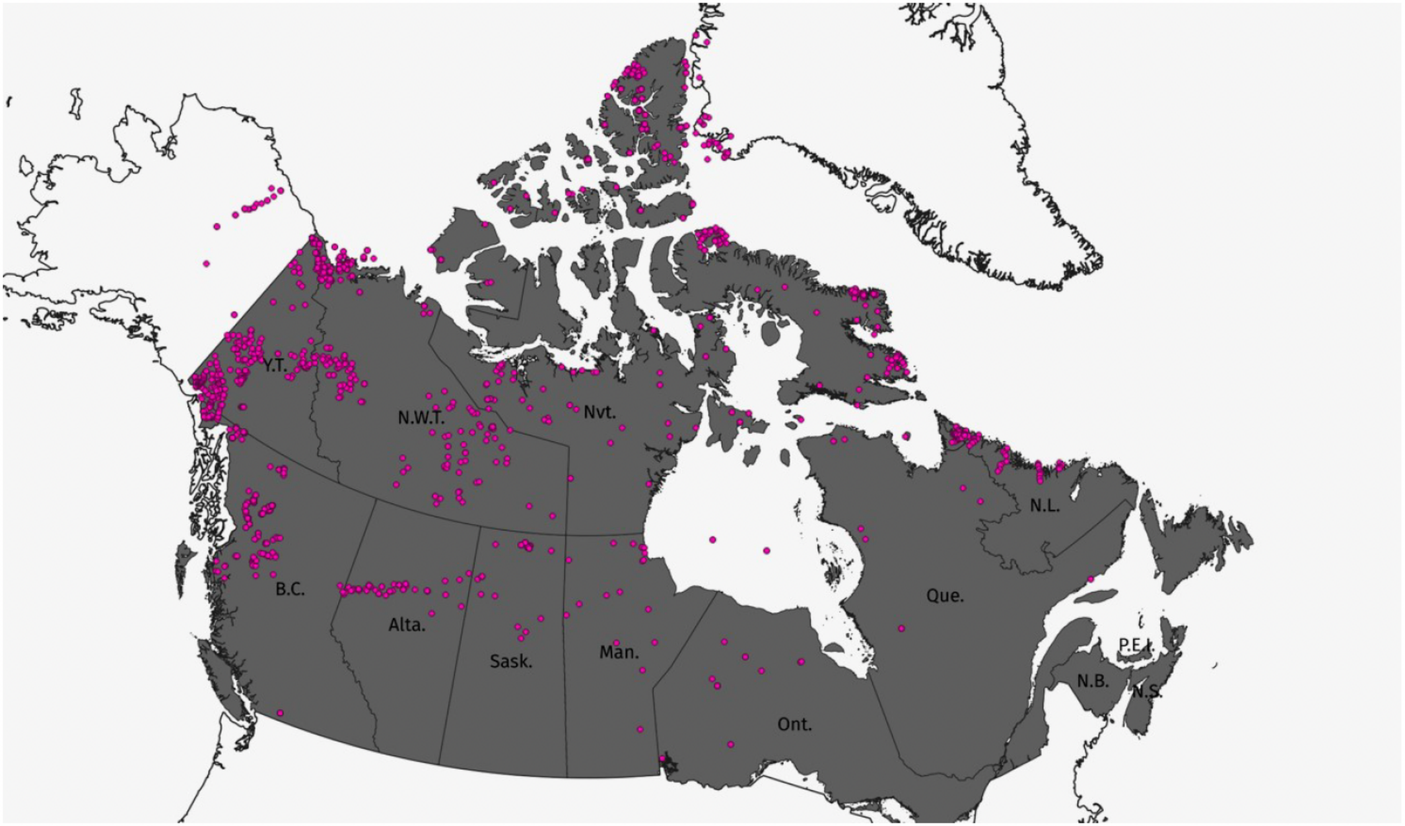
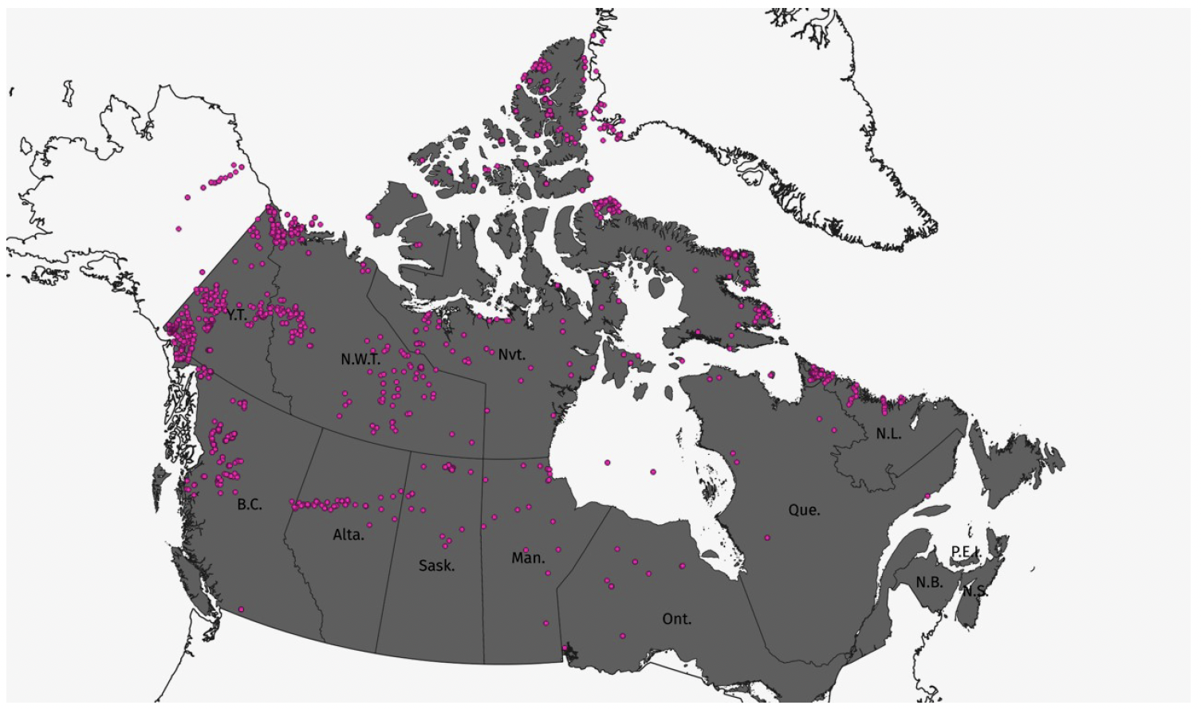
Locations of samples with LTT data in northern Canada. All published data are included in this report. Note: data from Alaska, Greenland and southern Canada were also extracted if included in the same publications as northern Canada LTT data. (Source: GSC Open File 9225)
1,427  Unique Samples | 50+ Years  Data Coverage (1970-2021) | 91  Data Sources
Data Accessibility: CATCH compilation data will be publicly accessible via Lithodat's open-access AusGeochem platform at
1. Executive Summary
1.1 What is the CATCH Database?
The Canadian ThermoCHronology (CATCH) database is a comprehensive national repository for low-temperature thermochronology data from across Canada. The database integrates 996 fission track datapoints and 762 (U-Th)/He datapoints from 1,427 unique samples, further divided into:
16,277 single grain fission track measurements
27,848 fission track length measurements
3,230 aliquots of (U-Th)/He data
The project represents a multi-year collaboration between Lithodat Pty Ltd and Canada's Geological Survey (Natural Resources Canada), involving extensive data mining, legacy data digitization, quality control, and standardization across 91 different data sources spanning five decades (1970-2021).
1.2 Relevance to GDAC-SA Project

The CATCH database demonstrates Lithodat's proven capability to address GDAC-SA's core challenges in national geological data integration:
Multi-Decade Data Integration: Successfully compiled and harmonized data from 50+ years of publications (1970-2021), including digital and analogue sources—directly analogous to GDAC's challenge of integrating historical and modern Saudi geological survey data
Legacy Data Digitization: Developed systematic approaches to extract data from paper reports, non-vectorized PDFs, and published figures (e.g., digitizing histograms, georeferencing sample locations)—critical for GDAC's historical data integration requirements
Complex Metadata Management: Captured comprehensive analytical metadata including sample coordinates, rock types, stratigraphic units, analytical methods, kinetic parameters, and quality control metrics—demonstrating expertise in geoscientific metadata frameworks
FAIR Data Principles: Designed database structure to be Findable, Accessible, Interoperable, and Reusable, with open-access delivery via AusGeochem platform—aligning with GDAC's open science mandate
National-Scale Geoscientific Infrastructure: Created standardized templates and workflows for ongoing data submission by Canadian researchers—providing blueprint for GDAC's data ingestion framework
Government Partnership Excellence: Multi-year collaboration with Natural Resources Canada (federal agency) demonstrates capability to deliver mission-critical infrastructure for national geological surveys
Critical GDAC-SA Alignment: The CATCH database solves the exact multi-decade data integration problem that GDAC-SA faces. Where GDAC must digitize and integrate 50+ years of Saudi geological survey data with inconsistent formats, CATCH successfully harmonized Canadian thermochronology data spanning the same timeframe with equally diverse data structures. The data extraction methodologies, quality control frameworks, and database architectures are directly transferable to the Saudi context.
2. Data Extraction and Curation Methodology
2.1 Multi-Source Data Integration
Data extraction involved extensive data mining of all LTT data and associated metadata for northern Canada from 91 different data sources. The project required specialized approaches for different data formats:
Data Format | Extraction Method | Quality Control
Modern Digital Publications | Direct extraction from digital tables (copy/paste to Excel) | Row-by-row validation against source
Analogue Paper Reports | Manual data entry from physical documents | Double-entry verification
Non-Vectorized PDFs | OCR extraction with manual correction | Character-by-character validation
Published  Figures/Histograms | Digital extraction using image analysis tools | Statistical comparison to published summaries
Maps Without Coordinates | Georeferencing using GIS software | Cross-validation with regional geology
2.2 Comprehensive Metadata Capture
At the sample level, CATCH captures extensive metadata to enable reuse and reinterpretation of historical data:
Sample Metadata: Name, coordinates, location name/description, location type, sampling method, rock type, stratigraphic unit, elevation
Analytical Metadata: Laboratory, analyst, analytical method, measurement date, equipment used
Kinetic Parameters: Dpar, chlorine content, radiation damage, etching conditions—essential for thermal history modeling

Provenance Metadata: Funding sources, chief investigator, publication reference, digital object identifier (DOI)
Quality Metrics: Number of grains analyzed, track counts, uncertainties, quality flags
2.3 Georeferencing and Spatial Integration
For publications where sample coordinates were not provided, locations were determined via systematic
georeferencing of geologic maps. This process involved:
Digital extraction of geologic maps from publications
Georeferencing maps using GIS software (QGIS, ArcGIS)
Digitizing sample locations from georeferenced maps
Cross-validation with regional geological frameworks
Assignment of confidence levels to georeferenced coordinates
3. Database Architecture and Data Model
3.1 Thermochronology-Specific Data Structure
The CATCH database employs a purpose-built data structure tailored to low-temperature thermochronology
requirements. The data model accounts for different thermochronometers, various analytical generations, and
corresponding metadata:
Fission Track Data Structure
FT Datapoints: Bulk fission track data for all samples (central ages, pooled ages, summary statistics)
FT Count Data: Fission track counting statistics (spontaneous tracks, induced tracks, uranium concentrations)
FT Single Grain: Individual grain ages and kinetic parameters
FT Length Data: Individual fission track length measurements
FT Binned Length Data: Length distributions digitized from published histograms
(U-Th)/He Data Structure
He Datapoints: Summary data for all samples (mean ages, weighted mean ages)
He Whole Grain: Detailed aliquot data (single grain or multi-grain analyses)
He Kinetic Parameters: Effective uranium (eU), grain dimensions, alpha ejection corrections
3.2 Modern Data Reporting Standards
The CATCH database structure adheres to international thermochronology community guidelines for data reporting:
Fission Track: Aligned with Kohn et al. (2024) community standards for fission track data reporting
(U-Th)/He: Follows Flowers et al. (2023a, b) guidelines for (U-Th)/He chronology data and uncertainty reporting
Extensibility: Database structure designed to accommodate future analytical methods and evolving reporting
standards
3.3 Data Reusability Framework
A critical design principle of CATCH is enabling functional reuse of historical data through modern analytical lenses.
This is essential because:
Evolving Kinetic Models: Laboratory-defined models for thermal diffusion and annealing are routinely updated
and improved
New Modeling Software: Advanced codes for numerical thermal history modeling are continually published
Big Data Approaches: Modern methods derive regional geologic histories from large LTT datasets requiring
comprehensive metadata
By capturing comprehensive analytical metadata, CATCH ensures that a single apatite fission track age from a 1970s
publication (with minimal reported metadata) can be reanalyzed using modern kinetic models alongside contemporary

samples with >3000 unique data entries per sample.
4. Data Coverage and Scientific Impact
4.1 Geographic Coverage
The northern Canada CATCH compilation provides comprehensive coverage of key tectonic and geological provinces:
Northern Canadian Cordillera: Extensive data documenting Mesozoic to Eocene mountain building and
exhumation
Arctic Islands: Data constraining burial and exhumation in Franklinian Basin and Sverdrup Basin
Canadian Shield: Critical data revealing dynamic cratonic response to far-field stresses through deep time
Eurekan Orogeny: Thermochronology documenting Eocene orogenesis along Arctic margin
4.2 Temporal Coverage and Data Density
996  Fission Track Datapoints | 762  (U-Th)/He Datapoints | 27,848  Track Length Measurements
The data span geological ages from Precambrian to Cenozoic, with the majority documenting cooling related to
Mesozoic and younger tectonic systems. This comprehensive temporal coverage enables:
Regional synthesis of exhumation and burial patterns
Identification of data gaps requiring new sampling campaigns Statistical approaches to understanding continental-scale tectonics Validation and calibration of geodynamic models
4.3 Research Applications Enabled by CATCH
The CATCH database infrastructure enables advanced research applications that were previously impossible without
centralized data access:
Big Data Thermochronology: Statistical analysis of continental-scale exhumation patterns (Boone et al. 2023,
Scientific Reports)
Machine Learning Applications: Training datasets for ML-based thermal history inversion algorithms Regional Synthesis: Identification of first-order tectonic events affecting Canada's bedrock evolution Gap Analysis: Systematic identification of under-sampled geological provinces requiring new data acquisition Legacy Data Reinterpretation: Re-analysis of historical data using modern kinetic models and thermal history
modeling codes
5. GDAC-SA Technical Alignment
5.1 Multi-Decade Data Integration Expertise
CATCH Database Challenge | Solution Implemented | GDAC-SA Applicability
Data from 1970-2021 in diverse formats | Multi-format extraction pipeline (digital, analogue, OCR, image analysis) | Directly applicable to GDAC's 50+ year historical data integration
Non-standardized metadata across decades | Flexible schema accommodating variable metadata completeness | Handles GDAC's heterogeneous historical Saudi survey data
Missing spatial coordinates | Systematic georeferencing workflow using GIS | Applicable to Saudi publications lacking GPS coordinates

CATCH Database Challenge | Solution Implemented | GDAC-SA Applicability
Data in published figures/histograms | Image digitization and data extraction tools | Critical for extracting data from historical Saudi reports
91 disparate data sources | Unified quality control and validation framework | Ensures consistency across GDAC's multi-source data streams
5.2 Government Partnership and Governance
Lithodat's collaboration with Natural Resources Canada (NRCan) on the CATCH database demonstrates:
Federal Agency Collaboration: Multi-year partnership with Canadian federal government geological survey
(GSC)
National Infrastructure Development: Building mission-critical data infrastructure for national geoscience
priorities
Official Publications: CATCH work published as GSC Open File 9225 with full government co-authorship
Long-Term Sustainability: Database designed for ongoing curation and expansion beyond initial compilation
Open Science Mandate: Full public accessibility via AusGeochem platform aligns with government open data
policies
5.3 FAIR Data Implementation
The CATCH database exemplifies FAIR (Findable, Accessible, Interoperable, Reusable) data principles:
Findable: Comprehensive metadata, DOI assignment (10.4095/pdreqf905k), publication in official GSC Open File
series
Accessible: Open-access delivery via AusGeochem platform, no authentication barriers
Interoperable: Standardized data formats, adherence to community reporting guidelines, API-ready structure
Reusable: Rich metadata enabling thermal history modeling, clear provenance and licensing, comprehensive
documentation
6. Future Expansion: Southern Canada and Thermal Modeling
The CATCH database is being expanded through a series of GSC Open Files:
Open File 9225 (Published 2025): Northern Canada compilation (this work)
Open File 2 (Upcoming): Southern Canada LTT compilation plus thermal history models and metadata
Open File 3 (Upcoming): CATCH database documentation and data submission templates for researchers
This phased approach demonstrates Lithodat's capability to deliver large-scale national infrastructure projects in
stages, with each phase building on previous work—directly relevant to GDAC-SA's phased implementation strategy.
7. Official Publication and Citation
Official Citation:
Powell, J.W., Kellett, D.A., Kohlmann, F., and McMillan, M., 2025. Canadian ThermoCHronology (CATCH) database: northern Canada
compilation; Geological Survey of Canada, Open File 9225, 1 .zip file.
Publisher: Natural Resources Canada, Geological Survey of Canada
ISBN: 978-0-660-74235-9
Catalogue No.: M183-2/9225E-PDF
ISSN: 2816-7155
Lithodat Authors:

F. Kohlmann (Lithodat Pty Ltd, Melbourne, Australia)
M. McMillan (Lithodat Pty Ltd & University of Melbourne, Australia)
Copyright: © His Majesty the King in Right of Canada, as represented by the Minister of Natural Resources, 2025
8. Key Takeaways for GDAC-SA
Proven National-Scale Data Integration: The CATCH database demonstrates Lithodat's capability to deliver national geological data infrastructure for federal government agencies. The project's scope (1,427 samples, 91 data sources, 50 years of legacy data) is directly comparable to GDAC-SA's requirements. Methodologies developed for CATCH—including legacy data digitization, multi-format extraction pipelines, georeferencing workflows, and FAIR data implementation—are immediately transferable to the Saudi geological survey context.
Government Partnership Excellence: Lithodat's multi-year collaboration with Natural Resources Canada (federal agency equivalent to Saudi Geological Survey) resulted in official government publications and long-term national infrastructure. This demonstrates capability to work within government procurement frameworks, deliver mission-critical infrastructure, and maintain partnerships through multi-phase projects—essential qualifications for the GDAC-SA contract.

